Steps:

1. Pull the image
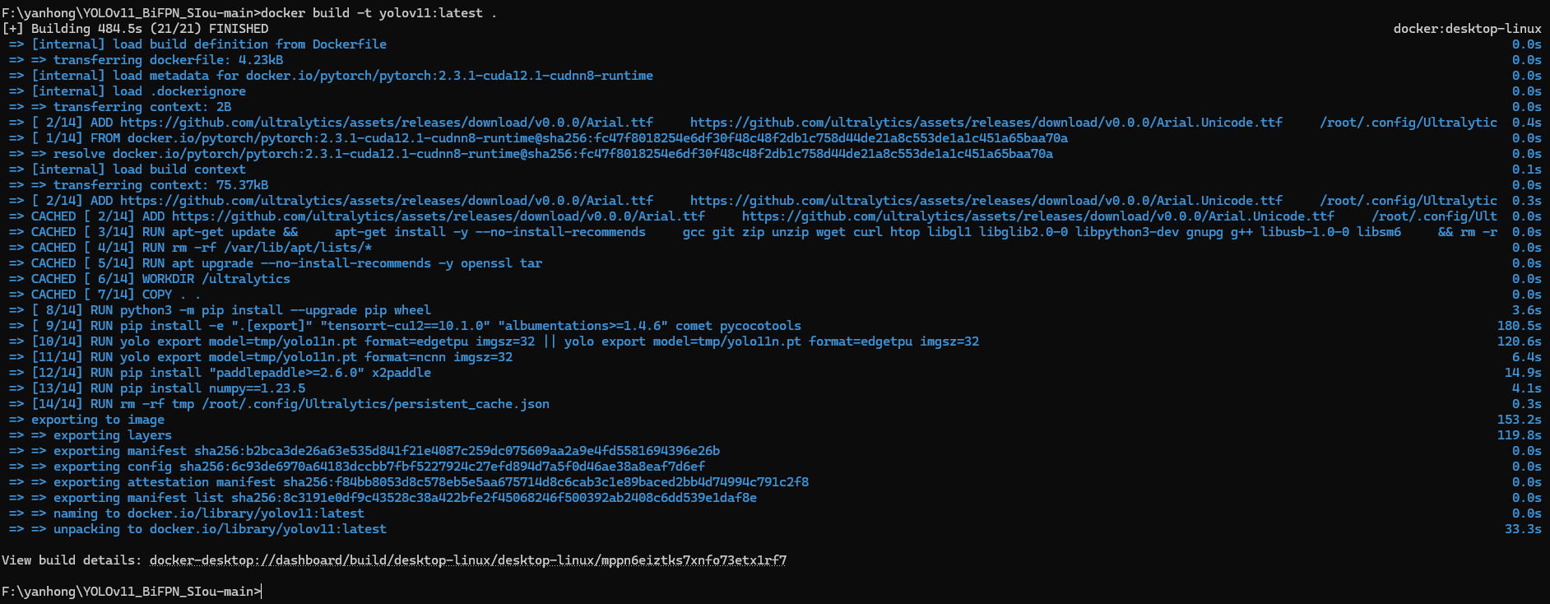
2. Create container

3. Into the container
4. Run the code: python mytrain.py

